# Workshop: Certificates Landing Page

Create a Web page (HTML5 + CSS3 + images) that looks and behaves like the screenshot below:

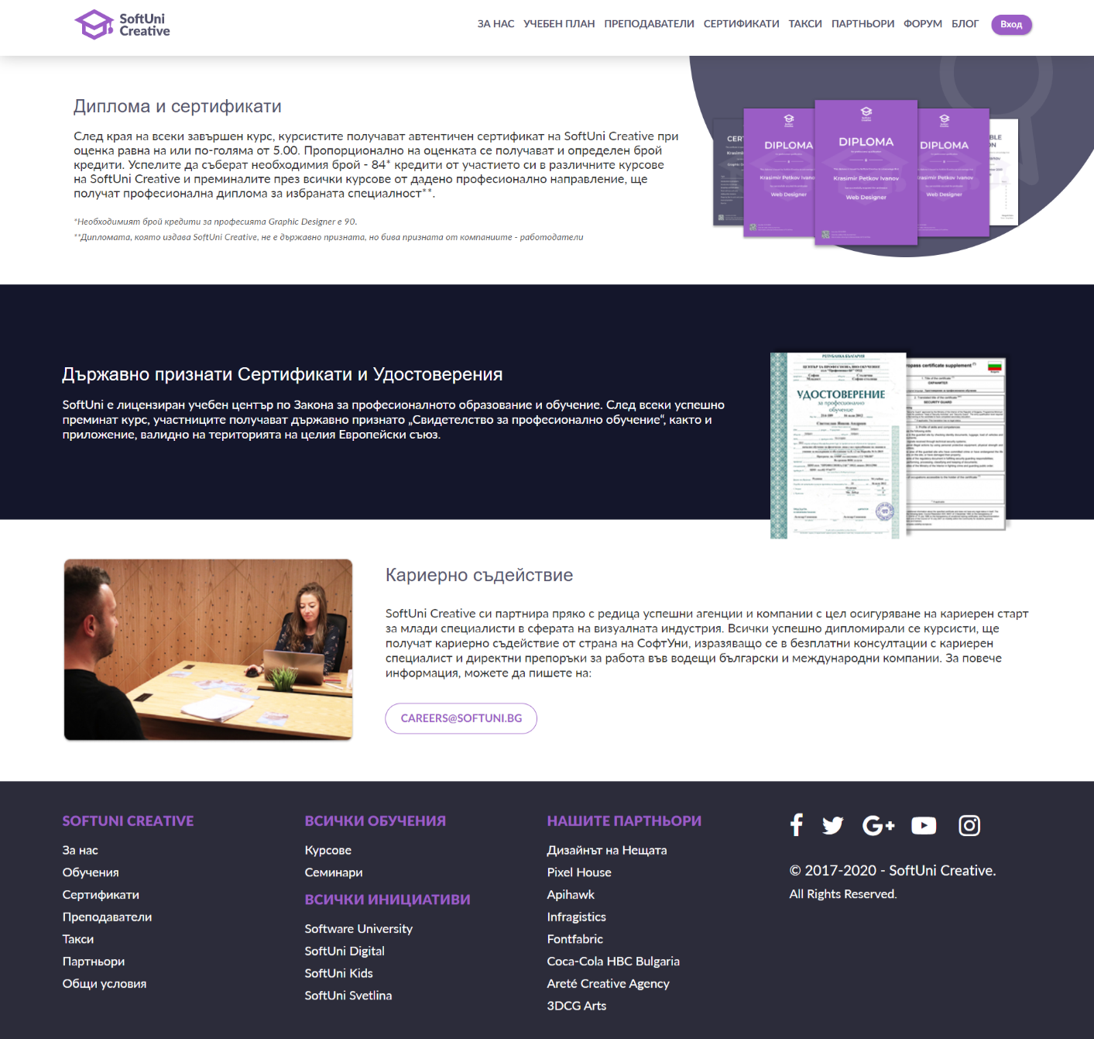

You are given the above screenshots + all required images.

### Output

The output should be valid **HTML5** + **CSS3** + **images** that implement the above web page.

### Constraints

* Use font 'Montserrat' for the heading
* Use font 'Lato' for the text
* The site should open correctly in the latest version of Chrome
* Pixel-perfect implementation is **NOT** required